Implement Client Server communication model using TCP

Steps involved how to Implement Client Server communication model using TCP below in the following order-
Program 1: To check given no is prime or not.
Step1 – Write a client program.
Step2 – Write a server program.
Step3 – Program output.
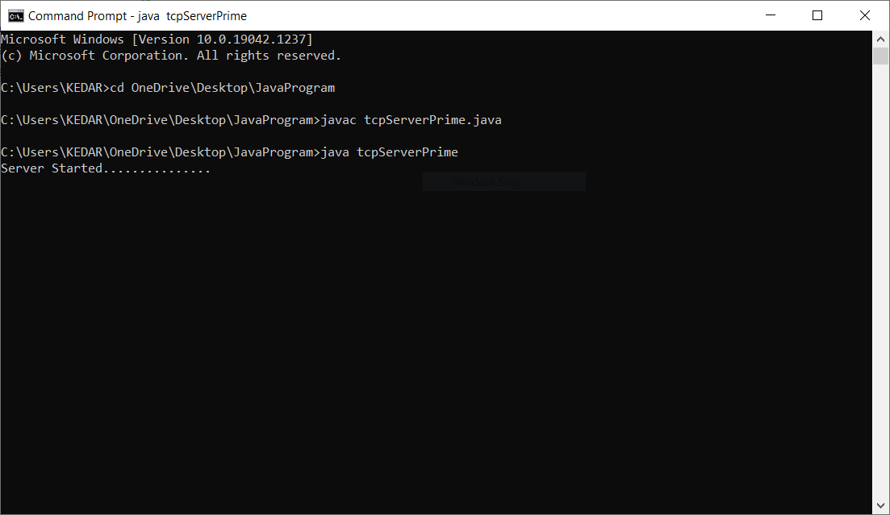
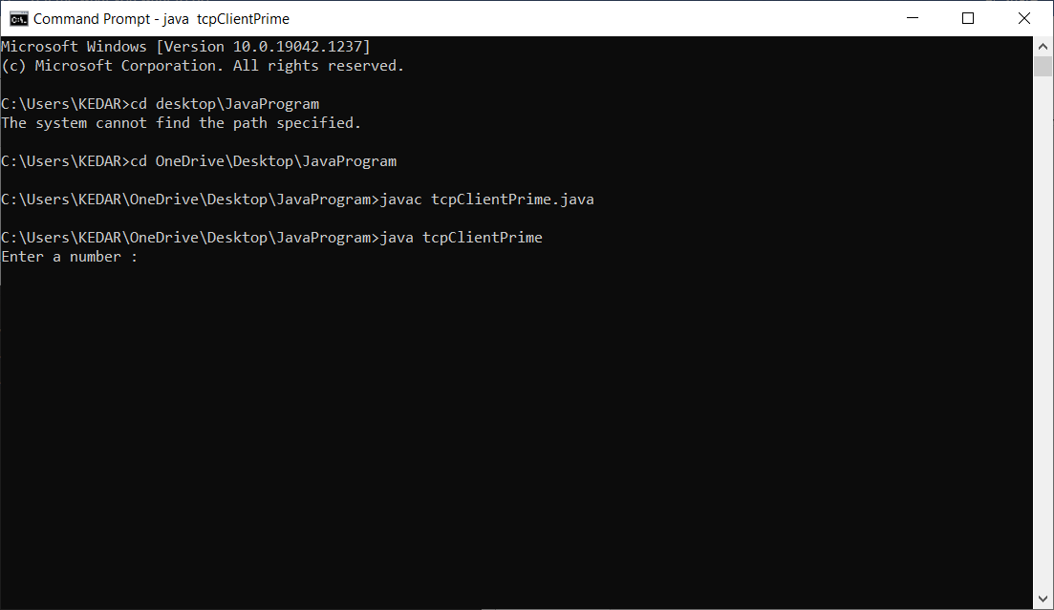
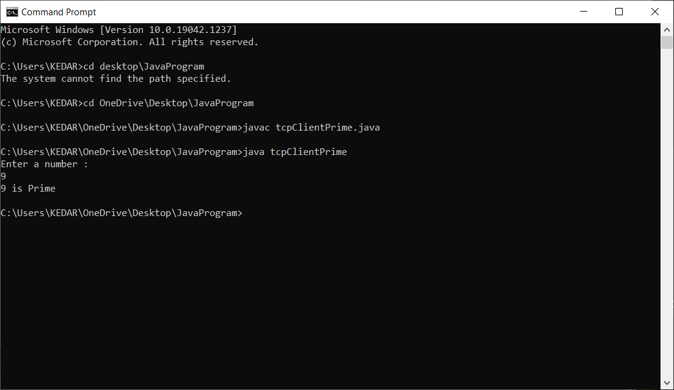
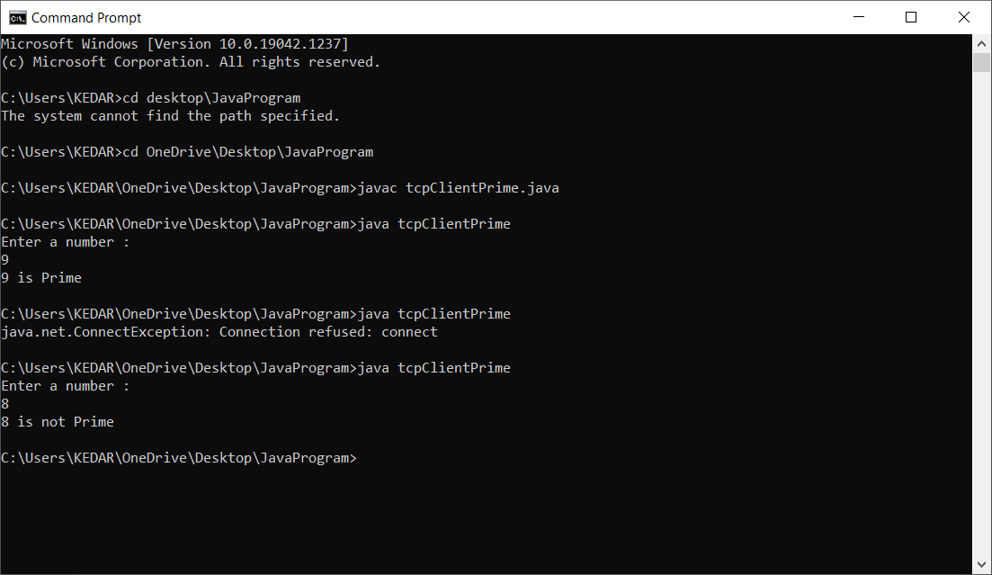

Program 2: Program to implement chat client and Server.
Step1 – Write a client program.
Step2 – Write a server program.
Step3 – Program output.
